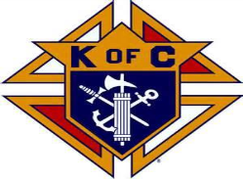
Knights of Columbus
Connecticut State Council 10 Pin Bowling Challenge
When: Sunday April 7, 2019
Registration @12:30pm with Bowling @ 1:00pm

Where: Wolcott Lanes, 955 Wolcott Road, Wolcott, CT http://wolcottlanes.com
Details:
- $68.00 per 4 person team (includes shoe rental).
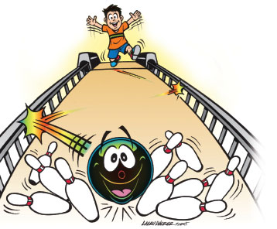
- Each team must have at least one person who is either a Brother Knight, a wife or girlfriend of a Knight, a Squire, or a Columbiette.

- This is a no handicap bowling event.
- Awards to be presented following bowling.

OPEN TO THE FIRST 20 TEAMS ONLY!!
Don’t Wait and Miss Out……..
Registration deadline is Friday, March 29, 2019

Complete and return the bottom portion along with payment
(Make check payable to “K of C, CT State Council)
Mail to: Maurice Goldberg 41 Coppermine Road, Farmington, CT. 06033
Home (860) 677-2922 E-mail: mr_ goldbe@rontier.com

- - - - - - - - - - - - - - - - - - - - - - - - - - - - - - - - - - - - - - - - - - - - - - - - - - - - - - - - - - - - - - - - - - - - - - - - - - - - - - - -
Team Representative: _________________ Phone # _____________ Email ________________

Council Name, Number, Location: _________________________________________________
Team Category: _____________________________
Bowler Name: ______________________________ Membership # _____________________
Bowler Name: ______________________________ Membership # _____________________
Bowler Name: ______________________________ Membership # _____________________
Bowler Name: ______________________________ Membership # _____________________

